**Companion for Zeo   
Users Guide**

**Version 1.0.2**

This User’s Guide is dedicated to the Public Domain.

The terms “Zeo” , “Zeo Professional Sleep Manager”, “Zeo Headband”, “Zeo Application”, “Zeo App” and “Zeo API” refer to hardware products, copyrighted software and documentation, and direct copyrights of Zeo, Inc (defunct) and its successors and assignees: https://en.wikipedia.org/wiki/Zeo,\_Inc.

The term “Zeo Data Viewer” refers to presumed copyrighted software owned and maintained by AlienRat Design: <http://www.alienrat.net/software/zeomonitor.html>

The term “Sleepyhead” refers to copyrighted software owned and maintained by Mark Watkins:  
<https://sleepyhead.jedimark.net/>

Table of Contents

[Introduction 1](#_Toc450822271)

[Android Permissions 1](#_Toc450822272)

[Choose how you want to use the App 2](#_Toc450822273)

[Section I. Sleep Session History and Trends 3](#_Toc450822274)

[Amended Sleep Results 3](#_Toc450822275)

[History Tab 4](#_Toc450822276)

[History Details – Using the Zeo App only 6](#_Toc450822277)

[History Details – Integrated use of Sleep Journal 8](#_Toc450822278)

[History Details – Amended Sleep Records 9](#_Toc450822279)

[Dashboard Trends 12](#_Toc450822280)

[Section II. Sleep Journal 13](#_Toc450822281)

[Sleep Journal’s Utility 13](#_Toc450822282)

[Sleep Journal Layout 14](#_Toc450822283)

[Typical Sleep Journal Use 15](#_Toc450822284)

[Section III. Exporting and Sharing 18](#_Toc450822285)

[Formats of Exportable Information 18](#_Toc450822286)

[Image Export Example 19](#_Toc450822287)

[Modes of Export 19](#_Toc450822288)

[Export Invocation 19](#_Toc450822289)

[Export Example 20](#_Toc450822290)

[Direct Email Outbox (Manual or Automated exporting) 21](#_Toc450822291)

[Expanded myZeo+ CSV file 22](#_Toc450822292)

[Section IV. Customization and Settings 28](#_Toc450822293)

[Customization 28](#_Toc450822294)

[Customize Attributes and Values 28](#_Toc450822295)

[Customize Doing Events 33](#_Toc450822296)

[Customize Before Attributes Order 34](#_Toc450822297)

[Restore Factory Defaults 34](#_Toc450822298)

[Settings 35](#_Toc450822299)

[Section V. Extras 40](#_Toc450822300)

[ZeoCompanion DB Backup 40](#_Toc450822301)

[ZeoCompanion DB Restore 40](#_Toc450822302)

[ZeoCompanion Alerts 41](#_Toc450822303)

[ZeoCompanion Error Log file 41](#_Toc450822304)

[Headband Commander 42](#_Toc450822305)

# Introduction

When the Zeo Corporation went out of business in 2013, that left users of the Zeo Professional Sleep Manager without the extended features offered by Zeo’s web site, including exporting of end-user’s data. However, the baseline Zeo Headbands and the Zeo Android App continue to remain useful even until today (2016). Recently, over 2,600 Zeo Pros were purchase by end-users from a discounter due to the recommendation of Steve Gibson from his “Security Now” podcast.

This ZeoCompanion App compliments the Zeo Android App, utilizing its published and public API, to offer those extended capabilities that the Zeo website offered but are now lost. These capabilities include data export to personal computers, sleep journal to augment the headband’s recordings, and sleep results trend displays.

# Android Permissions

In order for this App to function properly, it must have certain permissions granted. Before Android Marshmallow (6.0), these were granted in-bulk at installation. In Android Marshmallow (6.0) and beyond, these permissions are explicitly and individually asked for and granted after you fist use the App. The following table lists the permissions needed, why, and when they will be asked for.

|  |  |  |
| --- | --- | --- |
| **Permission** | **Why** | **When asked for** |
| **Write External Storage** | Store exports, database backups, and error logs | Every App startup until granted |
| **Zeo Read Sleep Records** | Read the Zeo App’s database | Every App startup until granted |
| **Internet** | Send Direct Emails of exports | If Direct Email is enabled, then every App startup until granted |
| **Bluetooth and  Bluetooth Admin** | Access to the Zeo Headband | Only if the Headband Commander is invoked |

# Choose how you want to use the App

This App provides three main capabilities to expand upon the limited features the baseline Zeo App provides: export, backup, and sleep journal. You choose which or all of those three you want to use:

C

A

B

* If all you want to do is export and backup, use the drop-down menu (**C**) to open Settings-> Journal to turn off “Enable Journal”. The App’s screen will simplify to just two tabs:
  + Use the Share/Export button (**A**) for exporting of Zeo App data. See Section III.
  + To backup the Zeo App database, first go to Settings->Database and turn on Zeo App replication. Then use the Backup button (**B**) to create a backup. See Section V.
* If you want automatic daily emailed exports, use the Settings->Email and   
  Settings-> Auto-Email screens to set that up.
* If you just want to record some supplements and before-sleep attributes that will export with your Zeo Data, use the Settings->Journal to turn off “Enable In-Bed”, “Enable Going”, “Enable During” and “Enable After” tabs. You can also customize those before-sleep attributes using the “Customize Attributes” menu item. See Sections II and IV.
* If you want to amend the Zeo data because it improperly records times you are awake as sleep, use the Settings->Journal to leave on the “Enable In-Bed”, “Enable Going”, “Enable During”, and “Enable After” tabs. See Section II.

# Section I. Sleep Session History and Trends

The ZeoCompanion accesses the Zeo App’s database through its published and public API to extract your sleep session records. Thus as a baseline, the ZeoCompanion App has access to the same data as the Zeo App, and can provide export and limited analysis features that the Zeo App lacks.

## Amended Sleep Results

Although the Zeo Pro Sleep Manager does a good job at sleep analysis for people with “normal sleep” patterns, it actually was not vetted nor verified for use by persons with sleep issues. Thus the Zeo Headband has particular trouble determining whether someone is motionless in-bed yet awake, or motionless in-bed and asleep. This is particular vexing for those people who use the Zeo Pro Sleep Manager, yet have “cannot fall asleep” issues, or “constantly wake up in the middle of the night” sleep issues.

The Sleep Journal described in Section II was designed to address these issues, and compliment the Zeo Headband’s analytics with information from the sleeper. Thus if you choose to utilize the event buttons on the Sleep Journal’s *In-bed*, *Going to Sleep*, or *During Sleep* tabs, the Sleep Journal will automatically create an Amended Sleep Record. This amended record is parallel to the Zeo App’s sleep record; both are maintained and both are always viewable. The Sleep Journal does not and cannot alter the Zeo App’s stored information.

On the *History* Tab and the *History Detail* screens described in the next section, if an amended sleep record is available, there will be differences to the on-screen displays that will provide you significantly more information, and means to switch back-and-forth between the baseline Zeo App sleep record and the ZeoCompanion amended sleep record. You also have similar choices when exporting or sharing sleep records as described in Section III.

## History Tab

The *History* tab shows a summation of each of your recorded sleep sessions (be they Zeo App only, or integrated with the Sleep Journal). This display is similar to the Zeo App’s own History Tab display.

A

B

C

If you press on a row, it will automatically invoke a History Details screen for the sleep record of that date.

**A:** The starting date and time of the sleep session, the resultant ZQ score, and the every 5-minute “display” hypnogram are shown. Red bars are awake time, Green bars are REM sleep, Light blue are Light sleep, and Dark blue are Deep sleep.

**B:** An optional summary of key sleep parameters that directly calculate the ZQ score. Use the Settings->History menu to remove it if desired. Text in Green means that row met your goals. Yellow means within 25% of the goal. Red means below 25% of the goal (or in cases of #Awakens or Awake time always Red since it’s always bad).

**C:** The Show Amended checkbox allows you to toggle the graphs between the baseline Zeo App sleep results, and the amended results based upon the extra Sleep Journal information. This checkbox will only be present if you have sleep records that do have amendments. You can use the Settings->Journal Amend menu to have this checked by default if you always want to see the amended results first.

**Showing Amended Sleep Results**



B

A

**A:** *Changes*: Note the additional “Awake” time intervals that the Sleep Journal inserted (as recorded by direct end-user input) compared to the prior screenshot.

**B:** *Changes*: Note that the key parameters have changed and worsened according to this amended sleep record.

## History Details – Using the Zeo App only

The History Details screen shows just one sleep session, and includes integrated data from the Zeo App and from the ZeoCompanion App databases. The baseline details display is shown if the Sleep Journal features of this App have not been used.

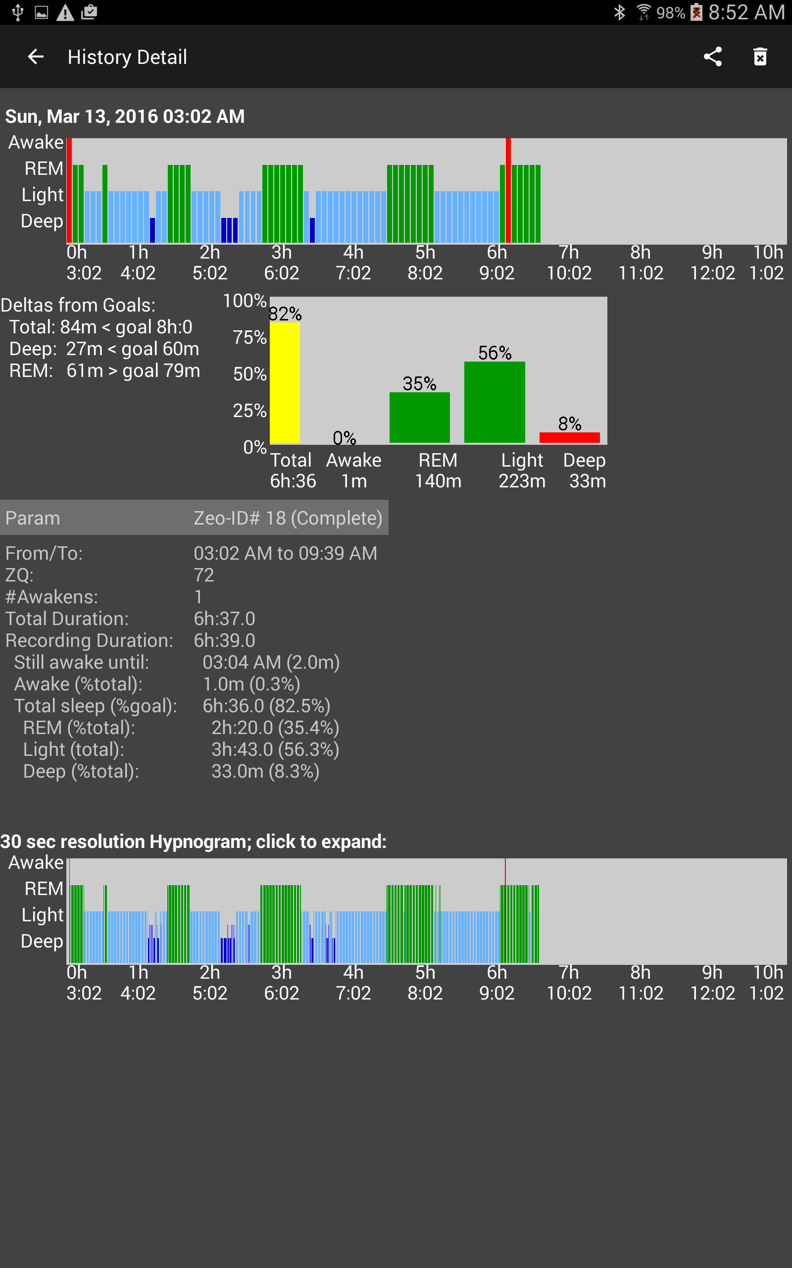

D

C

E

A

B

**A:** This date and hypnogram is the same as was shown on the History Tab, though the hypnogram is larger and has axis labels. Informational or warning messages may also be shown here.

**B:** This is a textual and graphical summary of your sleep session. The amount of total, deep, and REM sleep are compared to your goals. The graph shows the breakdown of the sleep stages in percent. The Awake, REM, Light, and Deep are all percentages of Total Sleep. The Total sleep is percentage of goal (typically 8 hours which is configurable in the Settings->Profile). The color code is: Green bars mean met your goals. Yellow bars mean within 25% of the goal. Red bars mean below 25% of the goal (or in the case of Awake time always Red since it is always bad).

**C:** These are the textual details of the sleep session from the Zeo App’s database. The Total Duration is based upon the From/To times. The Recording Duration includes only time intervals the Headband was actually able to take a reading.

**D:** This is the detailed hypnogram, scaled as same as the every 5-minute hypnogram. Depending on your screen size, it will be 30-sec, 60-sec, or 90-sec per bar. You will likely notice many differences between the upper and lower hypnograms where the Zeo Headband “averaged” the results for the upper 5-minute hypnogram and lost detail. You can click on this hypnogram, and a larger scrollable 30-second per bar version will appear in a popup window (see below).

**E:** The Share button will allow you to export or share just this record; see the Exporting and Sharing section. The Delete button will allow you to delete ONLY the ZeoCompanion portion of this sleep record in case it is wrong, incomplete, or mis-started. The ZeoCompanion cannot delete any records stored in the Zeo App itself.

The popup 30-second hypnogram is shown below. You can finger scroll it right and left. You can use a two finger “pinch” gesture to expand or contract it. And you can set the initial span of time shown in the Settings->History.



## History Details – Integrated use of Sleep Journal

The history details display shows more integrated information if the various features of the Sleep Journal are actively used. The enhanced features include annotated hypnograms, amended sleep records including side-by-side comparison, amended hypnograms, and sleep journal history.

## G:\Development\Mobile\Android\ZeoMobile\ZeoCompanion\Resources\Users Guide\ScreenShots\Screenshot_2016-04-15-08-52-28.png

G

D

C

B

A

E

F

**A:** *Additions*: The hypnogram is annotated with any events you may have entered via the Sleep Journal overnight. The codes are: **T**=In-bed tab Trying-to-sleep button, **S**=Going-to-sleep tab Still-awake button, **W**=While-sleep tab Woke-up button, **D**=While-sleep tab Did-something dropdown, **R**=While-sleep tab Retrying-to-sleep button.

**B:** *Additions*: the Sleep results from the After-sleep tab are also shown

**C:** *Additions*: the textual details of the sleep session from the ZeoCompanion App’s database are also shown. Note that the Recording Duration is shorter than the Total Duration due to the gap toward the ends of the hypnograms where the Headband failed to record. If the Sleep Journal was able to create an amended sleep record, all the matching amended details are shown side-by-side with the Zeo’s baseline data. If the Sleep Journal could not or did not amend the sleep record, then only a limited few data rows will be shown. The “red-ish” highlight indicates that the baseline Zeo App data is showing on the various graphs.

**D:** *Additions*: the hypnogram is annotated in the same manner with the same codes as ‘A’.

**E:** (no changes)

**F:** *New*: the Show Amended checkbox allows you to toggle the graphs between the baseline Zeo App sleep results, and the amended results based upon the extra Sleep Journal information (see next section). You can also press the two “cells” (the left-most currently has red-ish highlight) to toggle as well.

**G:** *New*: the complete attributes and events record from the Sleep Journal are shown.

The popup 30-second hypnogram also includes the annotations as shown below.



## History Details – Amended Sleep Records

As discussed at the introduction to this section, at times and for some people’s sleep issues, the Zeo Headband significantly over-estimates the amount of sleep actually achieved. By using the event recording capabilities of the Sleep Journal, times that you are truly awake can be notated even though the Zeo Headband records REM and Light sleep. The Sleep Journal can then create a secondary amended set of hypnograms and data that show the awake times that you have indicated, and a re-calculated ZQ score. Realistically this amending creates a “best case” and “worst case” of your sleep results and ZQ scores. Somewhere between these two points was your actual sleep experience.

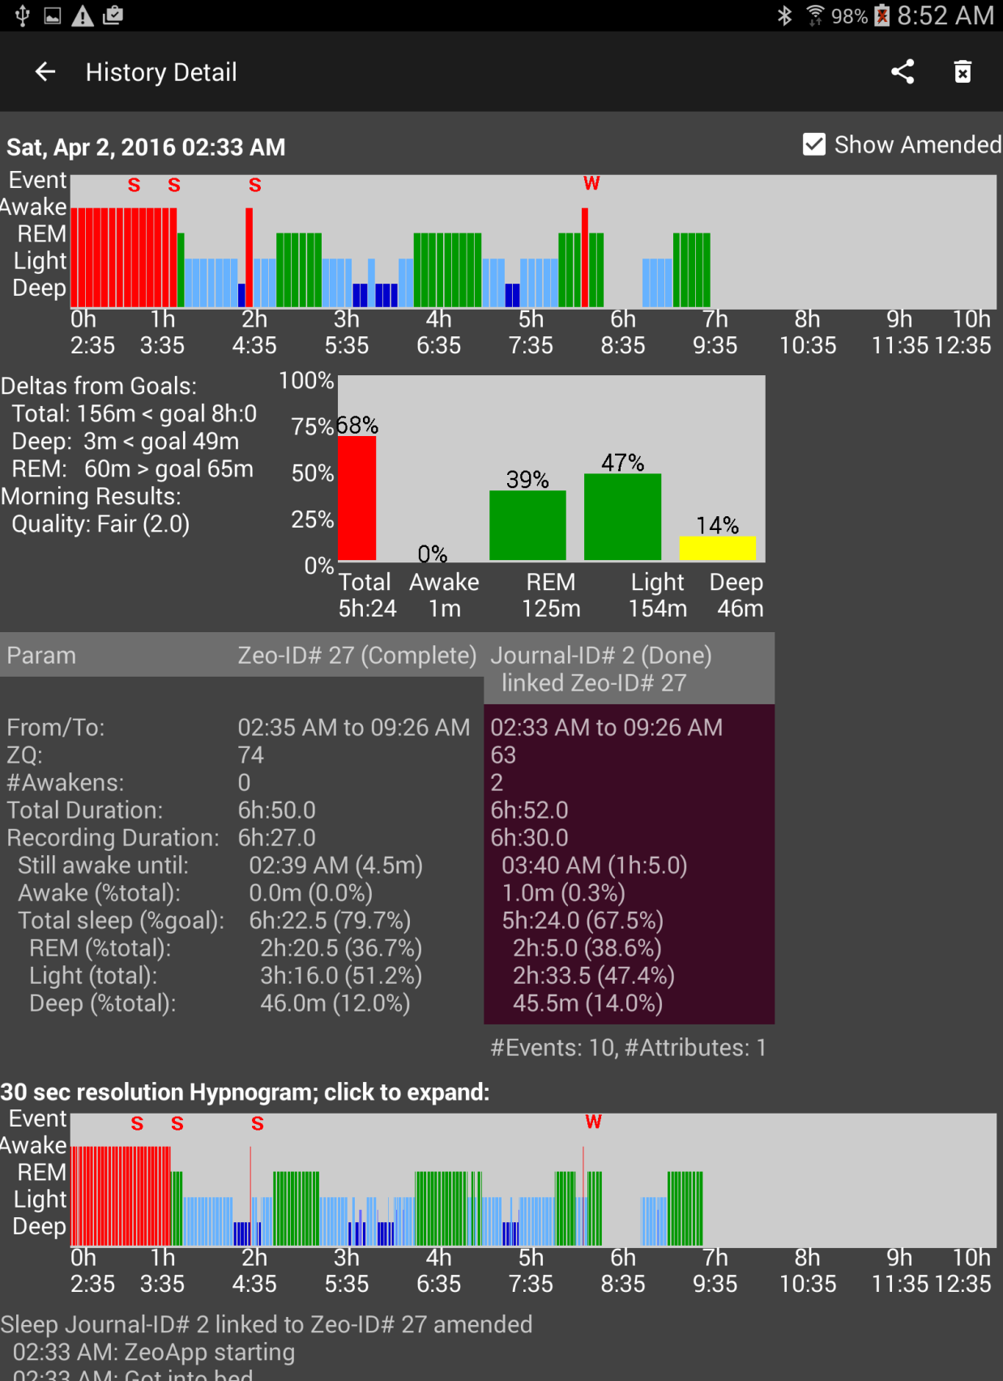

B

C

A

**A:** *Amendments*: Note the additional “awake” bars at the beginning of the sleep session where “still awake” events were recorded. Also note the additional “awake bars” where the third “still awake” event occurred, and the “woke-up” event occurred. The 30-sec detailed hypnogram has the same amendments.

**B:** *Amendments*: the text details and the graph have changed (and worsened) due to the additional Sleep Journal information about still-awake interval.

**C:** *Amendments*: notice the “second cell” now has the “red-ish” highlight since the amended results are showing. Also notice the total sleep time has been reduced, and the amount of Light and REM sleep has been reduced. The ZQ score dropped from 74 to 66.

The amended popup 30-second hypnogram also shows in more detail the amendments. For those that have “cannot-fall-asleep” sleep issues, the perception of time becomes distorted. A person may drift in-and-out of sleep with a continuity of thoughts and dreams. So the “still-awake” feature does not “backtrack” past a deep sleep interval.



A

## Dashboard Trends

Feature planned to be available in version 1.1

# Section II. Sleep Journal

The Sleep Journal feature of the ZeoCompanion is meant to be used in conjunction with the Zeo Pro Sleep Manager’s Android application. It is **NOT** designed to be a stand-alone sleep journal, and provides only limited information and analysis when used stand-alone.

The Sleep Journal feature is also optional. One does not have to use it at all, and it can be turned fully off using Settings->History. Or specific journal tabs that you do not want to utilize can be individually turned off in Settings->Journal.

The Sleep Journal‘s prior-to-sleep and after-sleep attributes and values are customizable. You can hide attributes that are not useful to your sleep issues. You can add new attributes that are useful . You can add, delete, and change the values that are selectable for each attribute. These capabilities are available in the menu under Customization.

Usage hint: you can use a swipe gesture to flip between tabs in addition to pressing a tab button.

## Sleep Journal’s Utility

For those with no sleep issues, the Sleep Journal feature provides little additional benefit beyond the Zeo Application’s own capabilities. However for those with sleep issues, the Sleep Journal can be used to augment the Zeo Application’s capabilities with your own experiments with supplements and sleep techniques by examining “inputs” (supplements, environment, techniques) and “outputs” (how well did you sleep).

The Sleep Journal offers specific features for specific sleep issues:

1. For all sleep issues, you can record what sleep-enhancing supplements you took prior to bed, and record information about your mood and sleep environment. These can be compared with your sleep results, and over a period of time you may be able to determine causes and effects that lead to better sleep.
2. For those that find it hard to fall asleep, and the Zeo Headband records you are asleep while are actually awake, you can record your “still awake” condition and optionally have the ZeoCompanion amend the Zeo App’s data to reflect your real sleep experience.
3. For those that consistently wake up one or more times at night, the “during sleep” feature can record when you woke up, what you did (if anything), and when you re-attempted to fall asleep.

As mentioned in Section I, the Sleep Journal offers the **optional** capability to amend the Zeo Application’s sleep data so it better reflects your issues with falling asleep or staying asleep. The ZeoCompanion cannot and does not alter the Zeo Application’s own database. All the optional feature does is provide a “second view” into the sleep records, and additional information in the exports.

## Sleep Journal Layout

The ZeoCompanion Sleep Journal feature has the following elements on the Android device:



F

D

E

A

B

C

**A:** The following Tabs are for the Sleep Journal feature: *Prior to Bed, In Bed, Going to Sleep, During Sleep, After Sleep, Journal Summary*. You can either press a tab button, or you can swipe left or swipe right.

**B:** The deep purple bar is the Journal Status Bar (JSB). In the middle it shows the status of the Zeo Application, the ZeoCompanion Application, and the overall Sleep Journal state. When ready for recording, it should show “Tonight” as overall status, “Idle” for the Zeo App status, and “None” for the ZeoCompanion App status. The two “LEDs” are described below.

**C:** Also part of the JSB, this shows the last-most recent sleep session (if any), and the LAST button. Pressing the LAST button will shift the Sleep Journal into limited editing mode for the prior sleep session. Pressing the LAST button will shift the Sleep Journal backward from Next to Tonight to Prior.

**D:** Also part of the JSB, this shows the next possible sleep session after Tonight’s. Pressing the NEXT button will shift the Sleep Journal forward from Prior to Tonight to Next.

**E:** The body of each Sleep Journal tab. Clickable “data entry” buttons and lists have the bright blue background or text color.

**F:** For the *In-Bed* and *After Sleep* tabs, the “Show hidden” checkbox will temporarily show all the normally hidden attributes in order to chose ones that are not often needed.

|  |  |  |
| --- | --- | --- |
| **LED color** | **Zeo App status** | **Sleep Journal status** |
| Gray | Idle; a *pulse* indicates a probe of the Zeo App | Idle |
| Green | Recording; a *pulse* indicates a probe of the Zeo App | Recording |
| Red | *Blinking:* Zeo Headband is not recording when it should | (not used) |

## Typical Sleep Journal Use

The Typical scenario to fully utilize the Sleep Journal alongside the Zeo Pro Sleep Manager is as follows; **the ZeoCompanion App MUST be left active in the “foreground” all night**:

| **Step** | **Description** | **JSB display** |
| --- | --- | --- |
| 1 | Before bed, the Journal Status Bar (JSB) should be showing the status seen to the right. If instead it is showing “Prior” press the NEXT button on the JSB. If it is showing “None” then press the LAST button. | G:\Development\Mobile\Android\ZeoMobile\ZeoCompanion\Resources\Users Guide\Cutouts\Journal_1.png |
| 2 | Just before bed, **go to the *Prior to Bed* tab**. Pick applicable values for the attributes that you wish to record for the night’s recording session. The JSB status will change as shown. To select an attribute’s value, press on the bright blue “-none-“ text. A list will popup with pre-defined values to choose from. Select a value and it will be recorded. Note that you can turn on the “Show hidden” checkbox to temporarily see all the possible attributes for rarely needed attributes. | G:\Development\Mobile\Android\ZeoMobile\ZeoCompanion\Resources\Users Guide\Cutouts\Journal_2.png |
| 3 | If you planning on doing something in bed other than sleeping, on the *In-Bed* tab, you can indicate when you get physically GOT INTO BED using the button, and indicate when you are doing various activities in-bed other than attempting to sleep. The JSB will remain as shown in step 2. The GOT INTO BED button can only be pressed once per sleep session. If you choose to wear your Zeo Headband during these non-sleep yet in-bed activities, steps 4 and 5 will occurring during this period. |  |
| 4 | **Put on your Zeo Headband**. The Zeo Companion App should detect when the Zeo App has started within 15 seconds. The JSB will change again as shown. | G:\Development\Mobile\Android\ZeoMobile\ZeoCompanion\Resources\Users Guide\Cutouts\Journal_4.png |
| 5 | Once the Zeo App starts to officially record, the JSB will change as shown. Now every event that is entered on the *In-bed*, *Going to Sleep*, or *During Sleep* tabs will be associated with your combined Zeo App and ZeoCompanion App sleep session records. | G:\Development\Mobile\Android\ZeoMobile\ZeoCompanion\Resources\Users Guide\Cutouts\Journal_5.png |
| 6 | **Get into bed and prepare for sleep.** Press the NOW TRYING TO SLEEP button to indicate you are actually attempting to sleep. The NOW TRYING TO SLEEP button can only be pressed once per sleep session. **Leave the ZeoCompanion App running in the foreground of your Android device!** |  |
| 7 | If you are a “cannot fall asleep” type of insomniac, and have noticed the Zeo App’s headband actually does not properly detect you are still awake for hours on end, **you can used the *Going to Sleep* tab to document your wakefulness**. After 30 seconds the display will dim as much as the Android device will allow to not impede your sleep (but it will be visible to your darkness vision).  Leave the ***Going to Sleep* tab open.** While in bed attempting to sleep, you can periodically hit the **STILL AWAKE** button. These still-awake events will be recorded in the Sleep Journal. |  |
| 8 | If you are a “wakes up in the middle of the night” type of insomniac, **you can use the *During Sleep* tab to document your awakenings**. After 30 seconds the display will dim as much as the Android device will allow to not impede your sleep (but it will be visible to your darkness vision).  You can press the WOKE UP button to record an event that you indeed woke up. If you do activities like go to the bathroom, you can record these events too. Then you can press the RETRYING TO SLEEP button when you get back into bed. To get the best record of the awake interval, be sure to always pair a WOKE UP with a RETRYING TO SLEEP. Only a WOKE UP event is counted toward the Number of Awakenings.  Also, after a RETRYING TO SLEEP, you can use the step 7’s **STILL AWAKE** sleep journal feature.  Note that you need to leave your Zeo headband either on your head or at least not plugged into its charger. If you plug the Zeo headband into its charger when you wake up for an extended period overnight, that will close both the Zeo App’s sleep session as well as the ZeoCompanion App’s sleep session. |  |
| 9 | The next morning after you have finished sleeping and are going to get out of bed, **go to the *After Sleep* tab and press the DONE SLEEPING button**. The JSB will change as shown. The DONE SLEEPING button can only be pressed once per sleep session. | G:\Development\Mobile\Android\ZeoMobile\ZeoCompanion\Resources\Users Guide\Cutouts\Journal_9.png |
| 10 | **Take the Zeo headband off and plug it into its charger**. The JSB will change as shown. | G:\Development\Mobile\Android\ZeoMobile\ZeoCompanion\Resources\Users Guide\Cutouts\Journal_10.png |
| 10a | Note that you do not have to press the DONE SLEEPING button if you so desire. If you just take off the Zeo Headband without pressing the DONE SLEEPING button. |  |
| 11 | **Enter in any after-sleep attributes into the *After Sleep* tab**, and they will be recorded into that “Prior” entry. |  |
| 12 | **Go to the *Sleep Journal* tab** to see a list of all the attributes and events that occurred in that “Prior” entry. |  |
| 13 | Press the NEXT button and the Journal is ready for the next night’s sleep. LAST button and the “Prior” entry will be re-shown. |  |

# Section III. Exporting and Sharing

The ZeoCompanion provides the capability to export integrated information from the Zeo Application and the ZeoCompanion’s Sleep Journal. The exports take the format of comma-separated-value (CSV) files, or PNG image files. The Zeo API from the now defunct Zeo web site provided CSV columns for all the sleep attributes as well as the sleep session’s intervals and hypnograms. The ZeoCompanion’s exporter takes advantage of those additional columns for the Sleep Journal.

## Formats of Exportable Information

Some third-party Apps that you may try to import into require the sleep data to be expressed in 30-second epochs, others need minutes; some need spaces within the hypnograms, others do not; and of course if you are importing into Excel or a similar spreadsheet then minutes is more intuitive to end-users. The below list of exports indicates which time-interval the export utilizes, and the filename will include either “epochs” or “minutes” in the filename.

Currently the ZeoCompanion can export information for the following uses in the following formats:

|  |  |  |  |  |  |
| --- | --- | --- | --- | --- | --- |
| **Export name** | **Export type** | **Export data format** | **Useful for** | **Data content** | **Format specifics\*** |
| Image/ZeoApp | Image | PNG | Social Media | Zeo & Journal | (n/a) |
| CSV/SS/myZeo+/minutes | CSV | myZeo+ | Spreadsheet | Zeo & Journal | minutes spaces  number;text |
| CSV/ZeoViewer/myZeo+/minutes | CSV | myZeo+ | Zeo Data Viewer | Zeo & Journal | minutes  no spaces  number;text  alterStartOfNight |
| CSV/Sleepyhead/myZeo+/epochs | CSV | myZeo+ | Sleepyhead | Zeo & Journal | epochs  spaces;  number  alterStartOfNight |
| CSV/SS/ZeoRaw/epochs | CSV | ZeoDB | Spreadsheet | Zeo | epochs  no spaces; |
| CSV/SS/ZeoRaw+/epochs | CSV | ZeoDB | Spreadsheet | Zeo+ dead | epochs  no spaces |

\* 1st: minutes or epochs in sleep record, 2nd: spaces or no spaces in hypnograms,   
 3rd: number;text or number in attribute columns;   
 4th: start of night changed to be timestamp of 1st data point in both hypnograms

The name of the export file will contain information about its export use and export data format. If you have entered in a first name or other name in Settings->Profile, that name will also be included in the export file’s name.

## Image Export Example

The format of the image is structured similar to that which is produced by the Zeo App. However, this graphic annotates the hypnogram with any events that were entered overnight using the Sleep Journal.

The horizontal bars on the lower half of the image show whether the goal for that sleep stage was or was not reached. The “goal line” is the middle of each horizontal bar. The “Light Sleep” bar deliberately does not have a goal.

## Modes of Export

The ZeoCompanion offers the following modes to export information off of your Android device:

1. **Leave in Files**: the export file is created and stored in the device’s “external storage” area. This area could be on a SD card, or just storage “inside” your device depending on how you have configured your Android. It can also be accessed via USB from a personal computer, or be access from your Android device via a File Manager app. The default external storage directory path is: Android/data/opensource.zeocompanion/exports/  
   However you can use Settings->Export to change the destination to one of the following external storage directories: Documents, Downloads, or Pictures
2. **Share**: the export file is created, then passed to the Android OS’s “sharing” feature. A second “Share for…” Android dialog will appear with various Apps that can utilize the file if you have so configured those apps, such as Email, Dropbox, Drive, Facebook, etc. The ZeoCompanion App has no direct interaction with these Apps.
3. **Direct Email**: if you configure your email account into the ZeoCompanion, it can then directly email you the file without needing your interaction on the “Share for…” Android dialog. You can optionally setup automated daily export emails of your sleep sessions.

## Export Invocation

* **From the Main screen**, via the Sharing icon, which will allow you to choose the format of export, the data range to select from, and the mode of export.
* **From a History Detail screen**, via the Sharing icon, which will export just the one integrated sleep record. You still chose the format of export, and the mode of export.
* **Automatic email export** is configured in the Settings. You must configure both “Email” settings and “Auto-Email” settings. An email test feature is also available.

## Export Example

When you press the Share icon on the mail screen, you are presented with the following dialog:



D

C

B

A

**A:** Choose the Format of Export

**B:** Check the box to export all records. The date picker will disappear.

**C:** Otherwise choose a starting date for the records you want to export.

**D:** Press a button to choose the Mode of Export. If you press Share, the following dialog will appear next to allow you to choose an App for transporting the export:

## Direct Email Outbox (Manual or Automated exporting)

In cases where you are using the Direct Email feature (manual or automated) and the email fails to send for some reason, those failed emails are stored in the Email Outbox. You can invoke the Email Outbox from the main menu. If there are items in the Outbox, the yellow mailbox icon will appear in the App’s main menu area.

Each Outbox entry shows the date and time of the email attempt, the To address and Subject, then the error information that was provided to the ZeoCompanion App.



All the Outbox entries are stored in your Device’s “external storage”. So the export CSV files are accessible via SD card or USB cable as an alternative to RESENDING them. The Outbox’s path is: Android/data/opensource.zeocompanion/outbox/

If the failure to send was temporary (such as a down email server) or due to mis-configuration of your email settings, once corrected you can press the RESEND button.

If the failure was due to an incorrect To address, you can press the TOADDR button, and correct the To Address, then press the RESEND button.

If the email failure cannot be resolved, pressing the DELETE button will permanently remove the email from the Outbox.

## Expanded myZeo+ CSV file

The ZeoCompanion exports an expanded CSV file that builds upon the original export file from the now defunct myZeo.com website. This export file remains compatible with third-party software such as the Zeo Data Viewer and Sleepyhead.

Some columns are composed of “subfields” such as the pre-defined attribute columns which have a “**numeric-value;text-value**”. Using a spreadsheet, you can either leave these subfields intact by choosing only a comma as a separator, or you can place these subfields into separate columns by choosing a comma and a semi-colon as separators.

**Warning: Exported Dates and Times can be a bit tricky.** The Zeo Sleep Record’s “Sleep Graphs StartTime”, “Start-of-Night” and ”End-of-Night” originate from the clock inside the headband itself (and not the clock within the Android device). However, all ZeoCompanion event timestamps are based upon the Android device’s clock (including when it detects the Zeo App state changes). If the Headband’s clock is out-of-sync with the Android device’s clock, then attempting to relate the timings can be difficult. Likely because of this, the original myZeo export format did not include seconds within the “Start of Night” and “End of Night” fields in the export just to fuzz up these inaccuracies.

The Zeo App does make an attempt to correct for discrepancy between the Headband and Android clocks (shown in the Zeo App’s Settings->Diagnostics it’s the Clock Offset row in milliseconds). The Start of Night and End of Night are automatically timeshifted by the Clock Offset. However the Zeo App performs that offset calculation only once when it pairs with a new headband. If the Android time-of-day changes or drifts, or the Headband’s clock drifts, this offset will become incorrect over time**. However, you can tap the highlighted number in the Zeo App’s Clock Offset Diagnostic screen, and the Zeo App will poll the headband and recalculate a new up-to--date Clock Offset.**

The CSV structure is composed into sections. There are in general no delineators between sections; however column headers are provided in the first line of an export CSV file. Each section other than the first are optional, meaning they may or may not be present depending upon the actual data that has been input, end-user Settings, and version of the App.

1. Original myZeo columns

Feature planned to be available in version 1.1

1. Extended Zeo Sleep Record columns
2. Sleep Cycle Results columns
3. Amended Sleep Record columns (optional)
4. Free-format Sleep Journal columns (conditional)

**Original myZeo columns** – always present; see the still-available documentation for this at:  
https://www.gwern.net/docs/zeo/2013-zeo-exportdatasheet.pdf

|  |  |  |  |  |
| --- | --- | --- | --- | --- |
| **Category** | **Qty of columns** | **Column header** | **Units** | **Notes** |
| Date & Time | 1 | Sleep Date | Date | Date only |
| Sleep Record | 1 | ZQ |  |  |
| 1 | Total Z | Min or Epochs |  |
| 1 | Time to Z | Min or Epochs |  |
| 1 | Time in Wake | Min or Epochs |  |
| 1 | Time in REM | Min or Epochs |  |
| 1 | Time in Light | Min or Epochs |  |
| 1 | Time in Deep | Min or Epochs |  |
| 1 | Awakenings | Qty |  |
| Date & Time | 1 | Start of Night | Date/time | May include secs; this time will be within the first non-zero digit in only the Detailed Sleep Graph |
| 1 | End of Night | Date/time | May include secs |
| Alarms | 1 | Rise Time | Date/time | Only for Sleepyhead; same as End of Night |
| 1 | Alarm Reason |  | Not currently used |
| 1 | Snooze Time |  |
| 1 | Wake Tone |  |
| 1 | Wake Window |  |
| 1 | Alarm Type |  |
| 1 | First Alarm Ring |  |
| 1 | Last Alarm Ring |  |
| 1 | First Snooze Time |  |
| 1 | Last Snooze Time |  |
| 1 | Set Alarm Time |  |
| Attributes | 4 | (Morning/Day attributes) |  |  |
|  | 1 | Notes |  | Not currently used |
| Attributes | 26 | (Before sleep attributes) |  |  |
| Attributes | 21 | (Custom attributes) |  |  |
| Hypnograms | 1 | Sleep Graph | digit=5min | Spaces may be between entries |
| 1 | Detailed Sleep Graph | digit=30sec |
|  | 1 | Firmware version |  | Not used |
|  | 1 | myZeo version |  | ZeoCompanion version# |

**Extended Sleep Record columns** – additional information in the Zeo Sleep Records that were not exported in the original myZeo format.

|  |  |  |  |  |
| --- | --- | --- | --- | --- |
| **Category** | **Qty of columns** | **Column header** | **Units** | **Notes** |
| Hypnograms | 1 | Sleep Graphs StartTime | Date/time | Starts on a 5 min boundary; this is the start time of the 1st digit in both hypnograms |
| Date & Time | 1 | Start of Night Headband | Date/time | Headband clock’s Start of Night (can be used to calculate Clock Offset) |
| Headband | 1 | Battery Start of Night Highest | (unknown) |  |
| 1 | Battery End of Night Lowest | (unknown) |  |
| 1 | Impedance Start of Night | (unknown) | Not currently used |
| 1 | Impedance End of Night | (unknown) | Not currently used |
| Sleep Record | 1 | Light Changed to Deep | Min or Epochs | Subset of “Time in Deep” that headband tagged as between Light and Deep. |
| 1 | Deep Sum |  |  |

**Sleep Cycle Results columns**

Feature planned to be available in version 1.1

To-be-defined in version 1.1 of this App.

**Amended Sleep Record columns** – only present if enabled in Settings;  
These columns follow the prior sections.

|  |  |  |  |  |
| --- | --- | --- | --- | --- |
| **Category** | **Qty of columns** | **Column header** | **Units** | **Notes** |
| Sleep Record | 1 | Amend ZQ |  |  |
| 1 | Amend Total Z | Min or Epochs |  |
| 1 | Amend Time to Z | Min or Epochs |  |
| 1 | Amend Time in Wake | Min or Epochs |  |
| 1 | Amend Time in REM | Min or Epochs |  |
| 1 | Amend Time in Light | Min or Epochs |  |
| 1 | Amend Time in Deep | Min or Epochs |  |
| 1 | Amend Awakenings | Qty |  |
| 1 | Light Changed to Deep | Min or Epochs |  |
| 1 | Deep Sum |  |  |
| Hypnograms | 1 | Amend Sleep Graph |  |  |
| 1 | Amend Detailed Sleep Graph |  |  |

Depending on how you set the following two Settings->Journal Amending, information will be placed in either the Original myZeo section or the optional Amended Sleep Record section as follows:

|  |  |  |  |
| --- | --- | --- | --- |
| ***Export Include Amended Section*** | ***Export Place Amended 1st*** | **The baseline Zeo Sleep Record will be placed at** | **The Amended Sleep Record will be placed at** |
| No | No | Original myZeo section | \*not exported\* |
| No | Yes | * If the row has an Amended Sleep Record then the baseline Zeo Sleep Record is \*not exported\* * If row does not have an Amended Sleep Record, then baseline Zeo Sleep Record is placed at the Original myZeo section | Original myZeo section |
| Yes | No | Original myZeo section | Amended Sleep Record section; column headers have the prefix “Amend”. |
| Yes | Yes | Amended Sleep Record section; column headers have the prefix “Base” | Original myZeo section |

**Free-format Sleep Journal columns**  
These columns will always be placed at the end of the export past any other prior sections. There will be a variable number of columns for each sleep record row, and there are no header columns for this content in the first line of the export CSV file.

|  |  |  |  |
| --- | --- | --- | --- |
| **Category** | **Qty of columns** | **Column contains** | **Units** |
|  | 1 | “$ZeoCompJournalAddtl” |  |
| Attributes | 1 | “$A” |  |
| vari | (Custom Additional Attributes) |  |
| 1 | “$/A” |  |
| Events | 1 | “$E” |  |
| vari | (Events) |  |
| 1 | “$/E” |  |
|  | 1 | “$/ ZeoCompJournalAddtl” |  |

If there are no events to export, then no $E … $/E columns will be present. If there are no custom additional attributes to export, then no $A … $/A columns will be present. If there are neither events nor custom additional attributes present, then the entire section will be omitted.

**Sleep Journal Events**

Events are encoded as: “**timestamp;event;optional-text**”. The *timestamp* is formatted as “MM/dd/yyyy HH:mm:ss” in a 24 hour clock relative to your local timezone. The *optional-text* only appears for the two “doing something events” when In-bed or During-sleep. The *events* are:

|  |  |  |  |
| --- | --- | --- | --- |
| **Event text** | **Corresponds to** | | **Notes** |
| 1ToBed | In-Bed tab | GOT INTO BED |  |
| 1NotTry | In-Bed tab | (activity) | Has optional-text |
| 1ZeoStart | (automated) |  |  |
| 1ZeoRec | (automated) |  |  |
| 2Going | In-Bed tab | NOW TRYING TO SLEEP |  |
| 2Awake | Going to Sleep tab | PRESS IF STILL AWAKE |  |
| 3Wokeup | While Sleeping tab | WOKE UP |  |
| 3Doing | While Sleeping tab | (activity) | Has optional-text |
| 3Retry | While Sleeping tab | RETRYING TO SLEEP |  |
| 4Done | After Sleep tab | DONE SLEEPING |  |
| 4ZeoEnd | (automated) |  |  |

**Sleep Journal Custom Additional Attributes**

Most attributes are placed into the Original myZeo columns, including the 21 fixed custom columns. However, if you have defined even more attributes that do not fit into the 21 allocated custom columns, all extra entered attributes will be placed into the free-format area.

Free-format custom Attributes are encoded as: “**sleep-stage;attribute;numeric-value;text-value**”. The *sleep-stages* will only be 1 (Prior to Bed tab) or 16 (After Sleep tab). The *attribute*, *numeric-value*, and *text-value* will be whatever you have defined in the Customize screens (see Section IV).

# Section IV. Customization and Settings

## Customization

There are two main types of customizable definitions.

* The “Doings” dataset allows you to choose the various activities shown in the *In-Bed* *and During Sleep* tabs of the journal.
* The “Attributes and Values” dataset allows you to chose what is shown in the *Prior to Sleep* and *After Sleep* journal tabs.

## Customize Attributes and Values

There are two types of Attributes: fixed pre-defined, and custom. The pre-defined attributes have fixed “slots” in the export record as defined by the Zeo website API. Twenty one custom attributes also have fixed “slots” in the export record, but you can add more custom attributes that will appear at the end of the export record.

Some tips about Values for the Attributes:

* It is usually quite difficult for most people to discriminate between fine subjective details between one choice and another. A lot of research has shown that a simple 3 to 5 item “Likert” scale is the most effective.
* A typical “Likert” scale has just three choices: Bad, Normal, Good with typical numeric values 1, 3, 5 respectively (or sometimes 2, 3, 4).
* A variant of that are binary decisions: No, Yes with typical numeric values of 1, 5 or 2, 4 (assuming that the Yes answer is more “good” than the No answer).
* An extended “Likert” would have 5 states such as: Terrible, Bad, Normal, Good, Excellent with numeric values 1, 2, 3, 4, 5.
* However, the ZeoCompanion App does not place any restrictions on the numeric value’s range. You could for example enter in supplement dosages in milligrams, and setup a few different values for the different dosage combinations you are trying.

Some tips about Attributes:

* The default list of Attributes as defined by the Zeo website API is far too long. Just like the Values, most people cannot discriminate between so many choices, and most do not want to think about and answer a 20 minute quiz before bed. You should turn off most of the Attributes, keeping only around 3 to 7 of the most significant Attributes that influence your sleep quality.
* The Prior to Sleep and After Sleep tabs provide a means to temporarily “show hidden” attributes, letting you select from time-to-time Attributes like Sickness that you likely rarely need.

When you pick the “Customize Attributes” menu item, the screen below will be invoked. Note that you can tab or swipe to get to the Custom Attributes & Values screen, or even swipe or tab to get to the Event Doings screen discussed in the next section.



D

C

B

A

**A:** This is a list of the pre-defined attributes from the Zeo website API. You cannot alter these attribute names, journal tabs, or export column names. Selecting a row will invoke the Values display (C) with the values configured for this attribute. The number before each attribute name is the “slot number” in the export data format.

**B:** These checkboxes allow you to show (checked) or hide (unchecked) the various attributes from the journal tabs. Therefore just uncheck those attributes that you are not interested in ever recording.

**C:** This is the Values display, which is always linked to the selected attribute. If you press the blue highlighted Value name or Value Numeric then an Edit Text dialog will appear (discussed below). You can also select the row for use with the Minus button.

**D:** Press the Plus button (+) to add a brand new Value. Press the Minus button (-) to delete the selected Value.

When you either press the Plus button or press the blue text Value entries, and Edit Text dialog will appear:



The Edit Text dialog lets you add or change the Value name, and lets you add or change the numeric quantity assigned to the value. When you generate an export, the numeric value is always included. You cannot leave either entry blank. And you cannot enter or change a Value name that duplicates one that already exists.

Working with the Custom Attributes tab is very similar to the above. You will note there are only two changes on the Custom Attributes and Values screen:

B

A

**A**: The Custom Attribute’s name is now blue highlighted, meaning you can press it to bring up an Edit Text dialog to change its name. The number before the attribute name is the slot# of the twenty-one fixed slot custom attributes in the export format.

**B**: The Plus button (+) will allow you to add a brand new custom attribute that will appear at the end of the export format. Those rows will not show a “slot#”. The Minus button (-) will allow you to delete one of those new non-slotted custom attributes. You cannot delete any of the twenty-one fixed slots, but you can hide them.

The Custom Attributes Edit Text dialog looks a bit different than the Values Edit Text dialog. 

You define the Attribute name as shown on the Android device plus a short “export column name” that will appear in the column headers of the export. You also choose whether this custom attribute appears in the Sleep Journal’s *Prior to Sleep* or *After Sleep* tabs. You cannot leave either text value blank. And the Attribute name cannot duplicate one that already exists.

## Customize Doing Events

Picking the “Customize Event Doings” menu item will invoke the following screen to allow you to add, delete, or alter events that are recorded on the *In Bed* or *After Sleep* tabs:



C

B

A

**A:** Provides a list of doing activities. Pressing on the row selects the row for use with the Minus button (in the example above “Gaming” is selected). Press on the blue highlighted text of the Doing name (regardless of whether the row is selected or not) to invoke the Edit Text dialog where you can change the name.

**B:** Provides check boxes that allow you to choose whether this activity appears on the *In-bed* and/or the *During Sleep* tabs of the journal. You can also select which one is shown by default (if more than one default checkbox is checked, the last-most in alphabetic order will be chosen as the default).

**C:** The Plus button (+) allows you to add a brand new Doing record. The Minus button (-) allows you to delete a selected Doing record.

## Customize Before Attributes Order

You can alter the order which the *Prior to Sleep* tab shows the long list of attributes. This ordering only affects the *Prior to Sleep* tab; export ordering is not changed.

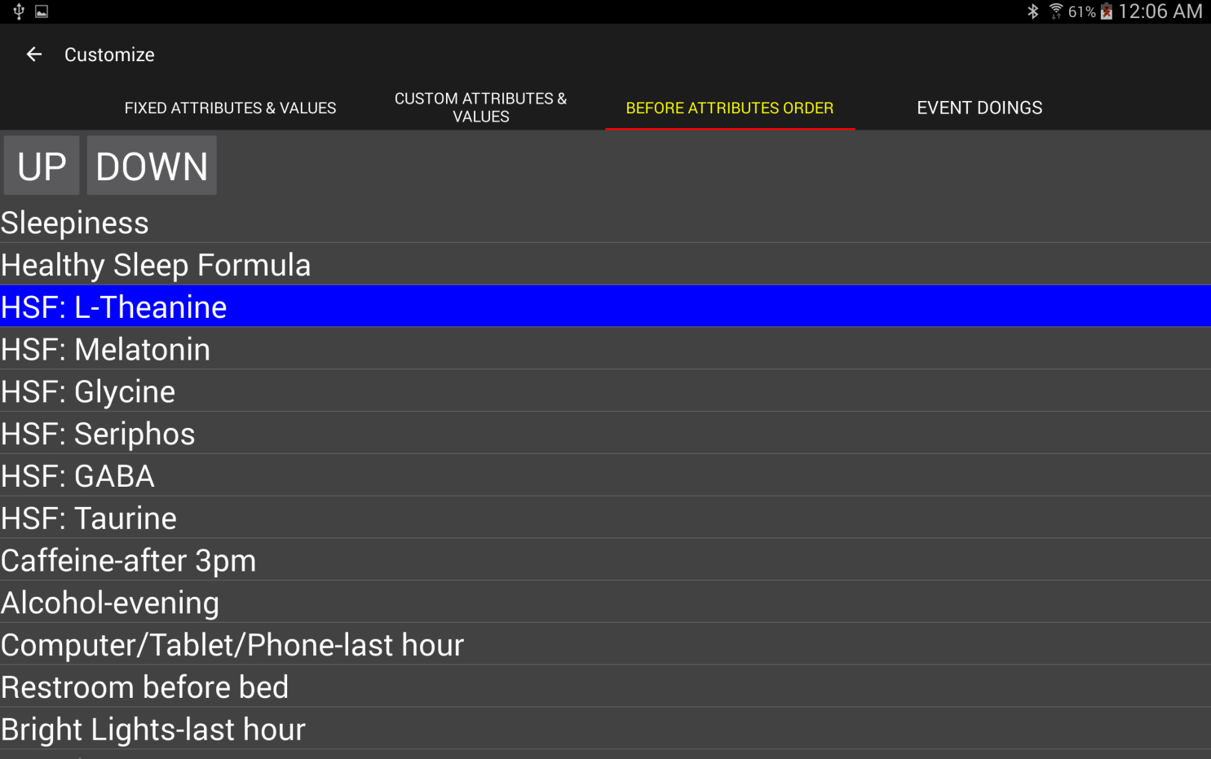

A

B

**A:** Select an attribute; it will be highlighted.

**B:** Press the UP button to move it up in the list; press the DOWN button to move it down in the list.

## Restore Factory Defaults

Choosing the “Restore Factory Defaults” option from the main menu and confirming the warning will reload all factory default attributes, values, and doings. All of your entered customizations will be permanently lost.

## Settings

The settings are organized into categories.

**Profile:**



Set your sleep goals: total hours of sleep, percent of Deep sleep, percent of REM sleep. These goals are used to color code information on the *History*, *History Detail*, and tabs. Also optionally set your first name (or other name as you like) that will be included in the names of your export files and backup database files (helpful if multiple persons in the same household are using Zeo Apps).

**History:**



You can choose which tab shows first when the ZeoCompanion App is first invoked. You can choose whether or not the white text details box shows on the *History* tab for each row. You can also choose the initial span of time first shown when the popup 30-second scrollable hypnogram is shown. To see more resolution (yet have to do more scrolling to see the entire hypnogram) choose a smaller time span. To see less resolution (and have to do less scrolling) choose a larger time span. In portrait orientation, on an Amazon Fire 7” or similar sized 600 x 1024 device, picking a value larger than 3.5 hours will result in bars less than one-pixel in width, and thus nothing shown in the 30-second popup hypnogram.

**Journal:**

**

You can choose to completely shut off the Sleep Journal. Or you can choose whether specific Sleep Journal tabs should show. You can turn off the notification sound made when the Zeo Headband fails to enter into Recording mode within 5 minutes of it being taken off its charger. And you can turn off the alert if the Zeo Headband’s clock appears out-of-sync with the Android device’s clock.

**Journal Amending:**

****

If you are using the Sleep Journal events feature to amend the Zeo’s sleep records, you can choose whether the History Tab and the History Details screen show first the unamended Zeo sleep records, or the amended ZeoCompanion sleep records. In either case, you can always switch between the two using the Show Amended checked on those screens.

For exporting, you can choose whether the CSV export contains both the unamended and amended data (in separate columns) [otherwise only one set of sleep data columns will be present). Separately you can choose whether the primary (and perhaps only) sleep data columns has the amended data [else will have the unamended data].

**Export:**

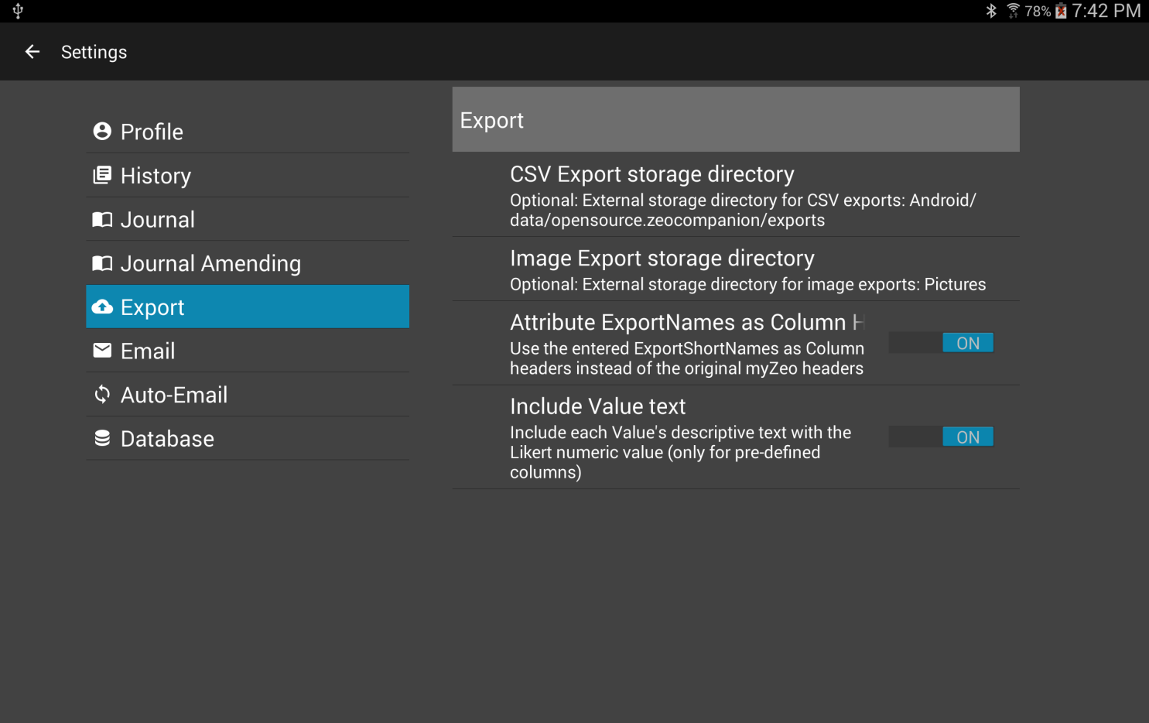

You can choose which directory to store either an image export or a CSV export. By default they are stored in the App’s external storage directory. However, you can change that to the Documents, Downloads, or Pictures external storage directory.

You can also choose whether to use the original Zeo website API column header titles, or whether to substitute in the ones you’ve defined for the Custom Attributes. You can also choose whether the fixed slots in the Zeo website API for the attributes contains just the numeric value, or both the numeric and textual values. If both are selected, they are stored as “number;text” using a semi-colon as the delimiter.

**Email:**

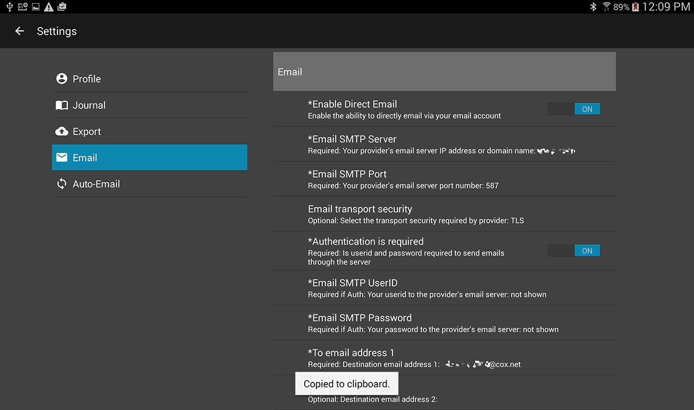

In order to utilize the optional Direct Email mechanism instead of the Android Sharing mechanism, you must configure in a SMTP server that you are allowed to send email through. If you have already configured one into another Android email App, you must re-enter it here. First choose Enable Direct Email. Then enter your SMTP server address and port number. Choose whether to use TLS, SLL, or none. Toggle on Authentication Required if so required, then enter your userid and password for accessing the SMTP server. Then enter in at least one destination email address to receive your exports.

At the bottom there is a TEST NOW button, and when pressed the ZeoCompanion App will attempt to send a test email to the destinations you have configured. If the email(s) fail, they will be shown as alerts on the screen.

**A note about security for your settings.** More recent versions of Android provide whole disk encryption to protect everything, including these email account settings. Earlier versions provide no protection and no secure storage. The ZeoCompanion App utilizes an industry common technique to store these email settings in an encrypted form. However, the unique per-device keys to the encryption are within your Android device and are easily recovered by a skilled technician with physical access to your device. So at best the ZeoCompanion App is obscuring your settings, but not truly protecting your settings. Please use a “low value” unimportant email account for sending Direct Emails.

**Automatic Email of Daily Exports**

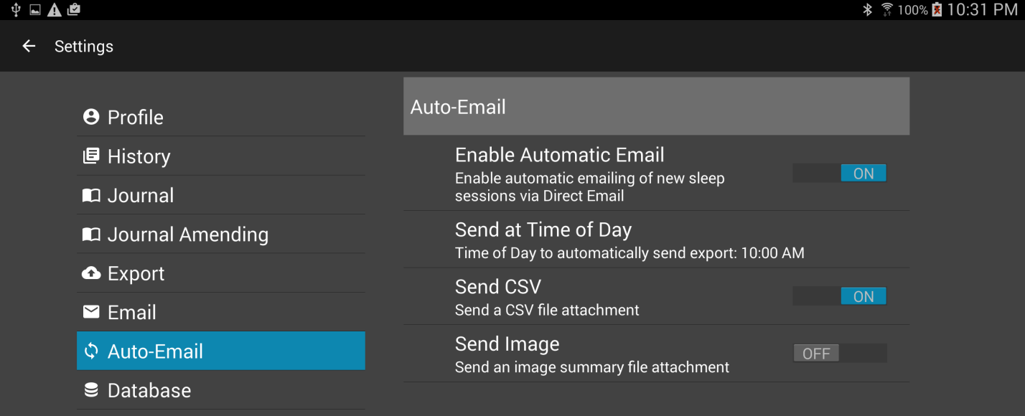

You can optionally have the ZeoCompanion App email you a daily export of your last night’s sleep session. You must first successfully configure the Direct Email settings. Choose Enable Automatic Email on the enable this feature. Set a time-of-day to automatically send the sleep results (perhaps in the later morning). For the present time, only the Send CSV is supported (Send Image is not yet coded into the app).

**Database Replication**



You can choose to replicate the Zeo App’s data within the ZeoCompanion’s database. This is wasteful of your Device’s RAM. However, this can be useful in several ways:

1. The Replicated data is included with the rest of the ZeoCompanion database, which you can back-up using the ZeoCompanion DB Backup menu item discussed in Section V. The Zeo App itself does not offer a way to backup its database individually.
2. You can move the ZeoCompanion database that has replicated Zeo App data to another Android Device that has the ZeoCompanion App installed, and even the Zeo App installed. If you have been unable to move the Zeo App and its data to the new Device, using the backup and restore described in Section V with the ZeoCompanion plus Zeo App Replicated data will effectively move all your Zeo App data to the new device (though that history data will only be seen in the ZeoCompanion App). Then you can use the Zeo App to record new sleep sessions, and on the Zeo Companion App you will have both “old” and “new” history available.

Feature #2 planned to be available in version 1.1

1. It can assist the Developers of the ZeoCompanion App to have a database emailed to them that contains all the data needed to debug an issue with the App.

The PURGE COPY button can be used to remove or re-generate this duplicated Zeo App data in the ZeoCompanion’s database. **Note: The ZeoCompanion App cannot and will not purge any data from the Zeo App itself.**  You will be asked to confirm the purge before proceeding.

To purge all the copied Zeo data, first set the “Replicate Zeo Database” option to off, then press the PURGE COPY button. To regenerate the replication, leave the “Replicate Zeo Database” setting on, and press the PURGE COPY button.

**WARNING**: If you do have copied sleep records from the Zeo App in the ZeoCompanion’s database, and those sleep records are no longer in the Zeo App (perhaps because you moved sleep records from one device to another), then performing this purge will permanently lose those sleep records that are no longer in the Zeo App.

# Section V. Extras

## ZeoCompanion DB Backup

The ZeoCompanion’s database can be copied into the Android Device’s “external storage”, then moved to a personal computer for backup purposes. This database can be restored into the ZeoCompanion App as described in the next section. The database backup can also be opened on your personal computer with a database tool that understands SQLite databases. It is also possible that Apps that can read the Zeo App database can also read the ZeoCompanion App’s database when replication of the Zeo App data is enabled.

Pressing the “ZeoCompanion DB Backup” menu item will copy the database to external storage in:  
Android/data/opensource.zeocompanion/internals/  
If you have entered in a first name or other name in Settings->Profile, that name will be included in the backup file’s name.

Please note this is only the ZeoCompanion’s database. It is not the Zeo Application’s database. **However, if you have turned on “Replicate Zeo Database” in the Settings, the ZeoCompanion database will have a copy of the Zeo App’s database which will then be included in the backup.**

## ZeoCompanion DB Restore

The command (if confirmed) will completely wipe out your existing ZeoCompanion database on this device, and install a previously backed up database. You will first be given a dialog in which you can choose which database file to restore. Then the App will check whether that database is restorable or not; if not you’ll be given an error message. If the database is restorable, you will be given a final Confirmation dialog to proceed or cancel.

The database to-be-restored must be in external storage on your Android device in:  
Android/data/opensource.zeocompanion/internals/

The normal reason to perform this action would be to move your ZeoCompanion database from one Android device to a new device. After a restore, some screens may still hold information from the prior database, but should re-organize themselves as you move from tab to tab.

If the database to-be-restore also contains replicated Zeo App database records, then those records become available to the ZeoCompanion App in addition to all those stored within the Zeo App’s own database. Note that the ZeoCompanion App CANNOT add, replace, or delete any of the records in the Zeo App’s own database.

If you have set a Settings->Profile name, and the database-to-restore also has a name (which is stored internally), they must be identical.

## ZeoCompanion Alerts

When there are situations that occurred during automated operations, alerts can get generated and stored. These alerts are accessible via the Alerts menu item. If there are any alerts, the yellow alert icon will show in the Main Window’s menu area. This will bring up a dialog where you can read and delete the alerts. Once all alerts are deleted, the yellow icon will go away. Alerts are generally only created by automatic email failures, Zeo database replication failures, and application aborts.



## ZeoCompanion Error Log file

Current versions of Android prevent end-users to access the hidden internal “logcat” error log file. This file is highly useful for debugging, but unless an end-user has an Android Debugger installed or has rooted their Android device, it cannot be accessed. The ZeoCompanion does try to intercept its own aborts, as well as intercept critical database errors. When these are captured, they are stored in external storage at: Android/data/opensource.zeocompanion/internals/error.logAn alert will also be posted to inform you errors are available and should be sent to the Developer.

## Headband Commander

There is a menu item for the “Headband Commander”. If you accept all the warnings, and invoke the tool, the ZeoCompanion App can be directly connected to the Zeo Headband, receiving its sleep broadcasts, and able to send commands to the headband.

However, due to limitations in both Android and the Zeo Headband, only one app at a time may connect to the Zeo Headband. In order for the ZeoCompanion App to connect to the Zeo Headband, you will have to use the Android Applications Manager to “Force Stop” the Zeo Application. Then the ZeoCompanion App can make a connection. Every time the headband disconnects from the ZeoCompanion App, the Zeo App gets automatically invoked and reconnects to the headband. So one must constantly Force Stop the Zeo App.

The Headband Commander can send commands to the Zeo Headband. Many of these commands are useful. Some commands can brick your headband and make it permanently unusable.

**Therefore use this feature only at your sole risk and sole responsibility. Mess up, and you have no one to blame but yourself for using this feature.**

However, this feature can be used to reset or reboot a headband, and explore how to invoke the Zeo Headband’s test mode to gain access to the waveform.

The Headband Command has a very simple GUI. Once you Force Stop the Zeo App, press the CONNECT button on the GUI, then press the button on the top of the Zeo Headband. The headband should immediately connect to the Commander, and the headband’s name and MAC address will be shown.

You should immediately get a headband “sleep record” transmitted from the headband to the app even though no sleep session is underway. If you put on the headband, you’ll see various messages from the headband as it progresses from starting to recording mode. Then the headband will send updated “sleep records” about every 5 minutes.

You can use the SEND button to send commands and inquiries to the headband. The safest Commands are “Request State Report” and “Request Sleep Report”. Using any other command could cause issues with your headband, and numerous of the commands have NOT been tested for their actual effects on the headband.

A Time Query can reset the headband’s internal clock, but most times it does not.

The Test messages are dangerous. Some will force your headband to disconnect and perhaps get the red blinking LED. The only safe ones are TEST LED ON=true and TEST LED ON=false. These two commands will control whether the headband’s LED is continuously illuminated when the headband is on your forehead.